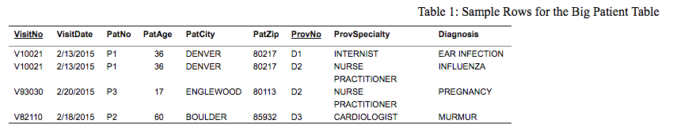

Insertion Anomalies:

It’s necessary to know VisitNo and ProvNo because primary key is the combination of these two.

Delete Anomalies:

If we just delete the provider of D2, we’ll lose information of visit V10021.

Update Aomalies:

If we change ProvSpeciality where ProvNo is D2, two row have to be changed.